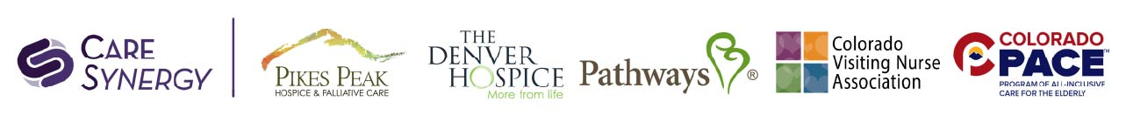
Discrimination is Against the Law
Care Synergy and Affiliates (Pathways, Pathways PACE, The Denver Hospice, OPTIO, Colorado PACE, Colorado Visting Nuse Association, CAPABLE, Pikes Peak Hospice & Palliative Care) complies with applicable federal civil rights laws and does not discriminate on the basis of race, color, national origin, age, disability, or sex (consistent with the scope of sex discrimination described at 45 CFR § 92.101(a)(2)). Care Synergy and Affiliates do not exclude people or treat them less favorably because of race, color, national origin, age, disability, or sex.
Care Synergy and Affiliates:
- Provides people with disabilities reasonable modifications and free appropriate auxiliary aids and services to communicate effectively with us, such as:
  - Qualified sign language interpreters
  - Written information in other formats (large print, audio, accessible electronic formats, other formats).
- Provides free language assistance services to people whose primary language is not English, which may include:
  - Qualified interpreters
  - Information written in other languages.
If you need reasonable modifications, appropriate auxiliary aids and services, or language assistance services, contact the Civil Rights Coordinator: the Director of Hospice Compliance. (888-765-7408)
If you believe that Care Synergy or Affiliate has failed to provide these services or discriminated in another way on the basis of race, color, national origin, age, disability, or sex, you can file a grievance with: Jennifer Niew/ Director of Hospice Compliance, who is the Civil Rights Coordinator. Her mailing address is :
8289 E. Lowry Blvd.
Denver, CO 80230
Telephone: 303-285-4777/ 888-765-7408
Email: hotline@hospicecompliance.org

You can file a grievance in person, by phone or by mail or email. If you need help filing a grievance, the Civil Rights Coordinator is available to help you.
You can also file a civil rights complaint with the U.S. Department of Health and Human Services, Office for Civil Rights, electronically through the Office for Civil Rights Complaint Portal, available at https://ocrportal.hhs.gov/ocr/portal/lobby.jsf, or by mail or phone at:

U.S. Department of Health and Human Services
200 Independence Avenue, SW
Room 509F, HHH Building
Washington, D.C. 20201
1-800-368-1019, 800-537-7697 (TDD)

Complaint forms are available at http://www.hhs.gov/ocr/office/file/index.html.

